FIRE BEHAVIOUR ADVISORY - CARIBOO FIRE CENTRE
Date issued: Monday, July 19, 2021
>>>An Extreme Fire Behaviour Warning is in effect today:<<<
- The advisory is for C3 and slash fuel types for an area from Tatla Lake to Riske Creek and for all of the 100 Mile Zone south of Timothy.
- From 13:00-22:00 there is potential for ROS of 10 m/min and intermittent crown fire when winds exceed 10 km/hr
- For slash fuel types there is potential for fire intensity to exceed 10,000 kw/m throughout the day, with rates of spread up to 20 m/min.
- This is a result of dry fuels and moderate winds.
- 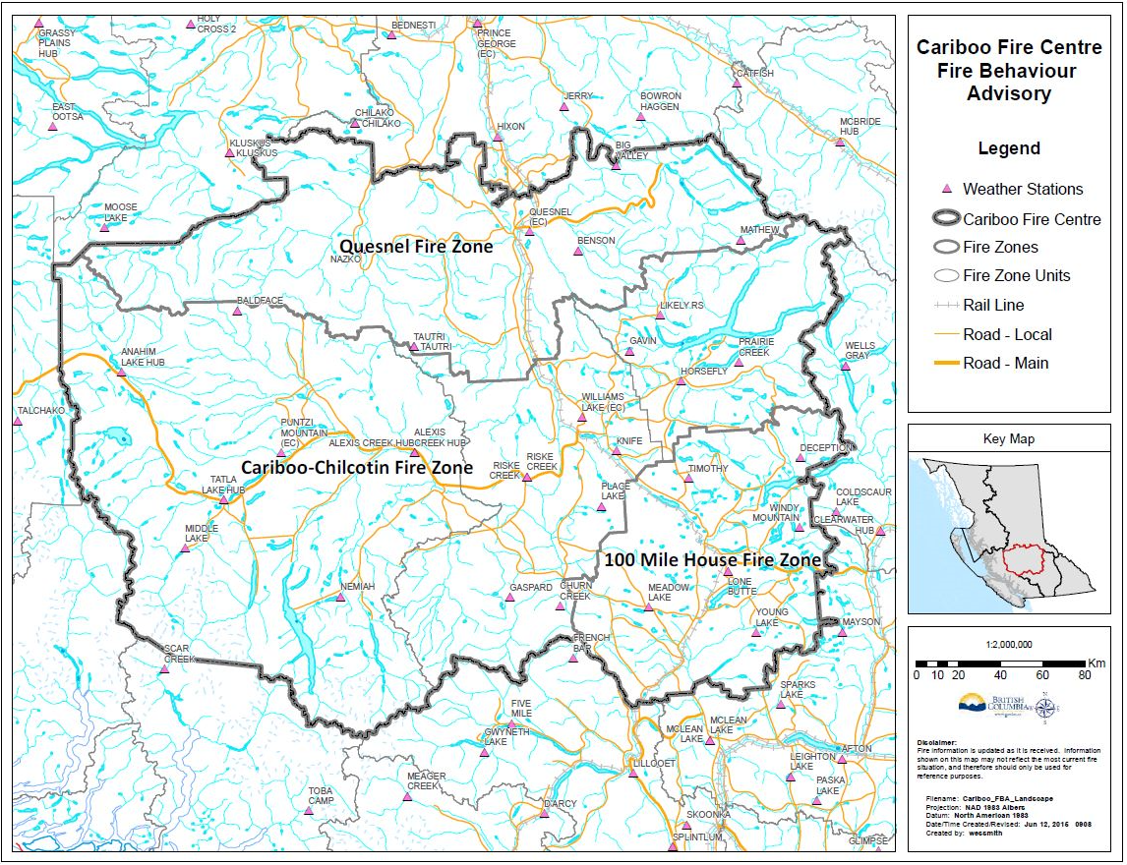
Potential for Intermittent Crown Fire from 13:00-20:00 with winds greater than 10 km/hr
Be aware of local topographic features and their effects on fire behavior. Practice LACES.
>>>Use your red book to make adjustments for your particular on site conditions!<<<

Prepared by: Ben Boghean (Fire Behavior Analyst) Approved by:

Distribution:
CIFAC YWL / CIFAC Quesnel / IA crew leaders in satellite bases / 100 Mile House zone / Central Zone / Quesnel Zone / Chilcotin Zone / Teams RO’s / IMT

